INDIAN SCHOOL AL WADI AL KABIR
DEPARTMENT OF SOCIAL SCIENCE
PRE -MID TERM EXAMINATION : 2022-23

CLASS: VI Max: Marks:30 Date: 24.05.2022 Time: 1 Hrs.

 | HISTORY (15 Marks)
I | Choose the correct answer: - | 2 Marks
1 | The place where rice was firstly grown is located in the ______________  (a) North of the Vindhyas (b) Suleiman hills (c) Banks of the Ganga (d) Garo hills. | 1 Mark
2 | Vindhyas are located in central ________.  (a) India (b) Himalaya (c) Magadha ( d) Kashmir | 1 Mark
II | Fill in the blanks: - | 2 Marks
3 | Manuscripts were written on ____________ | 1 Mark
4 | The name India was given by the Iranians and the _______________. | 1 Mark
III | Match the Following: - | 2 Marks
A B
5.Narmada Valley a. The first cities
6. Magadha b. Hunting and Gathering
c. The first big kingdom
IV | State True or False: - | 2 Marks
7 | Tributaries are smaller rivers that merge into a bigger river - | 1 Mark
8 | The people of the Andaman Islands are engaged in fishing, hunting, and collecting forest produce - | 1 Mark
V | Short Answers: - | 4 Marks
9 | Why do you think ordinary men and women did not generally keep records of what they did? | 2 Marks
10 | List one major difference between manuscripts and inscriptions. | 2 Marks
VI | Answer the Following: - | 3 Marks
11 | Who are the ‘Archaeologists’? What do they do? | 3 Marks
 | GEOGRAPHY (15 Marks)
VII | Choose the correct option: - | 2 Marks
1 | Which is the third nearest planet to the sun?  (a) Venus (b) Earth (c) Mercury (d) None of these | 1 Mark
2 | Asteroids are found between the orbits of  (a) Saturn and Jupiter (b) Mars and Jupiter (c) The Earth and Mars (d) All of these | 1 Mark
VIII | Fill in the blanks: - | 2 Marks
3 | The sun and the other stars are made up of __________. | 1 Mark
4 | Millions of galaxies make the ___________. | 1 Mark
IX | State True or False: - | 2 Marks
5 | The celestial bodies which have heat and light of their own are called stars- | 1 Mark
6 | The moon gets its light from the earth - | 1 Mark
X | Match the following: - | 2 Marks
A B
7.Edusat a. Astronomer
8. Aryabhata b. Galaxy
c. Artificial satellite
XI | Short Answers: - | 4 Marks
9 | How does a Planet differ from a Star? | 2 Marks
10 | Why Earth is called as a ‘unique planet’? | 2 Marks
XII  11 | Diagram Question: -  On the given diagram of the Solar System, name the marked one  A, B, C.  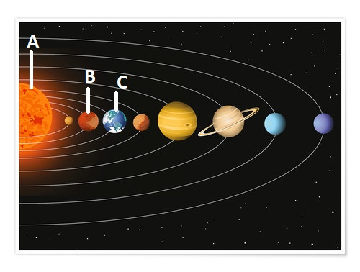 | 3 Marks

